The Minimal State DFA
We have characterized Regular languages in terms of NFAs (DFAs) and RLGs (LLGs). Throughout our discussions we have continually drawn an analogy between grammars and programs and DFAs and programs. In this section we begin to address for formal systems an issue that is always of concern for real programs, namely, “how can we make programs more efficient?” Specifically, we consider the problem of reducing the number of states in a DFA,
M = (Q, Σ, δ, q₀, A). In more colloquial terms, “can I design a DFA with fewer states that will do the same thing?” We know intuitively that not all equivalent DFAs have the same number of states. This is demonstrated by trivial examples. Consider M and M' illustrated in the figure below. It is clear that L(M) = L(M') = Σ*. In Figure A M has two reachable states, both of which are accept states. Clearly, this machine accepts all strings and is equivalent to the one-state DFA, M’; observe that M’ can be obtained from M by simply redirecting the transition, δ(1,b), from state 2 back to state 1, and eliminating 2 which, after this change, would no longer be reachable. In Figure B, we see that state 2 is unreachable in M. Thus the smaller, more efficient, M’, can be constructed by removing state 2.

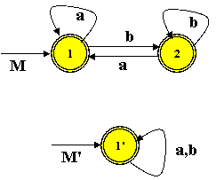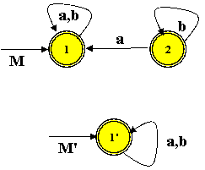
Figure A. Figure B.

These simple examples introduce two key ideas that will be exploited in the state minimization algorithm we present later: (a) the elimination of unreachable states, and (b) removing redundant or indistinguishable states. The first concept is obvious. The second notion is more vague and needs a formal introduction.

For any DFA, M, and any state q ∈ Q, we can define two sets of strings determined by q. The first set we shall denote as R_{q} = { x | δ*(q₀,x) = q }. This is just the strings that leave M in state q. The second set determined by q is S_{q} and is given by S_{q} = {y | δ*(q, y) ∈ A }. These are the strings that would allow M to accept, once M has reached state q. Sets Rq and Sq are illustrated graphically in Figure C.

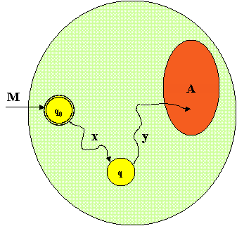

Figure C. A typical x ∈ R_{q} and a typical y ∈S_{q}.

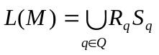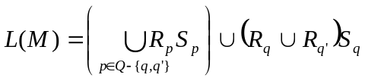Given these sets, the following is true about L(M).
Now suppose that S_{q} = S_{q'} for two distinct state q and q'. To see that this is possible, refer to our machine M in Figure A. Clearly S₁ = S₂ = Σ*. However, assuming q and q' are both reachable states of M, then it is never true that R_{q} = R_{q'}, in fact R_{q} ∩ R_{q'} = Φ. For suppose that x ∈ R_{q} ∩ R_{q'}. Because δ∗_{M} is a function we have δ∗_{M}(q₀,x) = q = q', contradicting our assumption that q and q' are distinct. The consequence of the fact that S_{q} = S_{q'} is that the equation for L(M) can now be written as:
This says that, with respect to what M will eventually accepts, there is no difference in the behavior of M once it reaches q or q'. We say that q and q' are indistinguishable. Restating, we can merge q and q' into one state by "rewiring" M in the following way. If p ≠ q' is any state in Q and δ(p, a) = q', then redefine the transition to go to q instead; that is, redefine δ(p,a) = q. Then, remove q' from M and any other states that might become unreachable as a result. If one of q and q' is q₀, then remove the state that is not q₀. After this rewiring, R_{q}(new) = R_{q}(old) ∪R_{q'}(old). S_{q}(new) = S_{q}(old) and L(M_{new}) = L(M_{old}).
Definition BX-1. So, more formally, we say that q and q’ are indistinguishable states if and only if (S_{q} = S_{q'}), where S_{q} and S_{q’} are defined as specified above.

Now that we know how to reduce the size of a DFA, the next problem we face is how to identify pairs of indistinguishable states. It turns out that indistinguishable is an equivalence relations on the set of reachable states of a DFA. We develop this fact formally in the following discussion.

Definition BX-2. Let M = (Q, , , q₀, A) be a DFA, and let q₁ , q₂  Q. Then the relation  is defined on Q as follows: q₁ ≡ q₂ if and only if z * [δ*_{M}(q₁, z)  A  δ*_{M}(q₂, z) A]; this is equivalent to saying that q₁ , q₂ are indistinguishable.

Corollary-BX2.  is an equivalence relation on Q. Furthermore, q₁ ≡ q₂ if and only if x *, δ*_{M}(q₁, x)  δ*_{M}(q₂, x).
Proof. It is trivial to show that  is an equivalence relation on Q. This we leave to the reader. We must now show that any pair of states, reachable from q₁ and q₂, must also be indistinguishable.

By Definition BX-2, q₁ ≡ q₂ if and only if z * [δ*_{M}(q₁,z) A  δ*_{M}(q₂,z) A].
This holds if and only if x,y *[ δ*_{M}(q₁,xy) A  δ*_{M}(q₂,xy) A] if and only if x *
[y *[ δ*_{M}(δ*_{M}(q₁,x),y) A  δ*_{M}(δ*_{M}(q₂,x),y) A]] if and only if
x *[ δ*_{M}(q₁,x)  δ*_{M}(q₂,x) ]. QED
The next theorem gives us an iterative algorithm for computing the relation ≡ on the state set of a given DFA, M. It also establishes that the minimal state DFA accepting L(M) can be derived from ≡ by treating equivalence classes [q]≡ as states of this machine.
Theorem BX-1. Let M = (Q, , , q₀, A) be a DFA where all states in Q are reachable. For all
k  0 define the relation _{k} on Q as follows: q₁ ≡_{k} q₂ if and only if z *^{k} [δ*_{M}(q₁,z) A  δ*_{M}(q₂,z) A]. (We say that q₁ and q₂ are indistinguishable by strings of length k or less.) Then
(a) ₀ = {Q-A, A} and for each k  0, q₁ ≡_{k+1} q₂ if and only q₁ ≡_{k} q₂ and if for every
a , (q₁,a) _{k} (q₂,a); and
(b) for some k  n-2, where n is the number of states in M,  = _{k} ; and finally,
(c) L(M) = L(M_{L} ), where M_{L} = (Q', , ', [q₀]≡ , A') , where
Q' = { [q]≡ | q Q},
A' = { [q]≡ | q A}, and
for all a  , '([q]≡, a) = [(q,a)]≡.
Proof(a). Applying the definition for k = 0, we see that q₁ ₀ q₂ if and only if [q₁ = δ*_{M}(q₁,λ) A  q₂ = δ*_{M}(q₂,λ) A]. Thus ₀ = {Q-A, A}. Now consider q₁ _{k+1} q₂.

By definition of _{k+1} , z *^{(k+1)} [δ*_{M}(q₁, z) A  δ*_{M}(q₂, z) A], then z *^{k} [δ*_{M}(q₁,z) A  δ*_{M}(q₂,z) A]. Thus q₁ _{k} q₂. But because *^{(k+1)} = Σ*^{k}, q₁ _{k+1} q₂ holds if and only if a  [z *^{k} [δ*_{M}(q₁, az) A  δ*_{M}(q₂, az) A]]. And this holds if and only if a  [z *^{k} [δ*_{M}((q₁,a),z) A  δ*_{M}((q₂,a),z) A]. And finally this holds if and only if a  [(q₁,a) ≡_{k} (q₂,a)].

Proof (b). We first show that if ≡_{k} = ≡_{k+1}, then ≡_{k} = ≡. It should be clear that q₁ ≡ q₂ if and only if for all k ≥ 0, q₁ ≡_{k} q₂. What we will show is that if ≡_{k} = ≡_{k+1}, then ≡_{k} = ≡_{k+n}, for all n ≥ 1. This is easily established by induction on n. The basis (n = 1) is given by assumption. Now suppose q₁ ≡_{k+n+1} q₂. Then by part (a) applied to ≡_{k+n+1} we have, q₁ ≡_{k+n+1} q₂ if and only if q₁ ≡_{k+n} q₂ and for all a ∈Σ [ δ(q₁,a) ≡_{k+n} δ(q₂,a)]. But by our induction hypothesis, ≡_{k} = ≡_{k+n}, and we have q₁ ≡_{k+n+1} q₂ if and only if q₁ ≡_{k} q₂ and for all a ∈Σ [ δ(q₁,a) ≡_{k} δ(q₂,a)]. But this is the same as saying q₁ ≡_{k+1} q₂. And then, since ≡_{k} = ≡_{k+1}, it follows that q₁ ≡_{k+n+1} q₂ if and only if q₁ ≡_{k} q₂.
Thus ≡_{k} = ≡_{k+n+1} and the induction is complete.
To finish (b) suppose M has n states and assume both Q-A and A are non-empty. Then by part (a), ₀ = { Q-A, A}. Suppose that ₀ ≠ ₁, then ₁ must have at least one more equivalence class than ₀ (at least 3). Furthermore, because q₁ ≡_{k+1} q₂ implies q₁ ≡_{k} q₂, then at least one class of ₁ was formed by splitting one of the classes of ₀. Thus if we consider the progression of equivalence relations, ₀, ₁, …, _{k}, where |₀| = 2 and |_{j+1}| ≥ |_{j}|+1, then since the |_{k}| cannot exceed the number of states of M, it follows that k ≤ n-2 and _{k} = _{k+1}. Thus for any j > n-2, it must follow that _{j} = _{k} = .

Proof(c). The first point to observe is that ML is a well-defined DFA, not NFA. The only possible challenge to this statement might arise from the definition of δ’. This

STATE MINIMIZATION ALGORITHM
Let M = (Q, , , q₀, A) be a DFA. The minimal state DFA equivalent to M can be computed in the following way.
Step 1: Eliminate the unreachable states of M to obtain M’ = (Q’, , , q₀, A’). The only difference between M and M’ will be that Q’  Q and A’  A.
Step 2: If A’ = , then L(M) = L(M’) = , and both are equivalent to the 1-state DFA,
M’’ = ({q₀}, , ’’, q₀, ), where ’’(q₀,a) = q₀, for all a . On the other hand, if A’ = Q’, then L(M) = L(M’) = Σ*, and both are equivalent to M’’ = ({q₀}, , ’’, q₀, {q₀}), where ’’(q₀,a) = q₀, for all a .
Step 3: If A’  and Q’-A’ , then do the following.
For k = 0, 1, … , compute _{k} until _{k} = _{k+1}. The minimal state DFA equivalent to M’ is the machine, M_{L} = (Q', , ', [q₀]≡ , A') , where Q' = { [q]≡ | q Q}, A' = { [q]≡ | q A}, and for all a  , '([q]≡, a) = [(q,a)]≡. Use _{k} as .

Example 30. Constructing the minimal-state DFA for a given regular language L.
Consider the DFA, M, shown below for L(M) = { aaa, aba, baa, bba }.
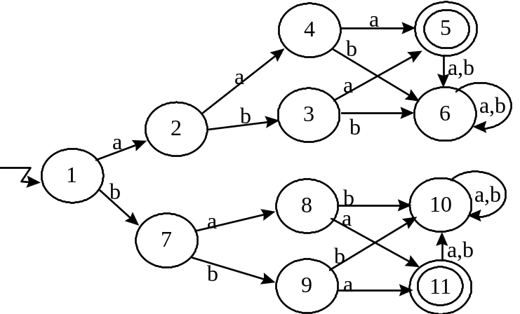

₀ = { A:[1, 2, 3, 4, 6, 7, 8, 9, 10], B:[5, 11] }
 | A |  |  |  |  |  |  |  |  | B
δ | 1 | 2 | 3 | 4 | 6 | 7 | 8 | 9 | 10 | 5 | 11
a | A | A | B | B | A | A | B | B | A | A | A
b | A | A | A | A | A | A | A | A | A | A | A

₁ = { A:[1, 2, 6, 7, 10], C:[3, 4, 8, 9], B:[5, 11] }
 | A |  |  |  |  | C |  |  |  | B
δ | 1 | 2 | 6 | 7 | 10 | 3 | 4 | 8 | 9 | 5 | 11
a | A | C | A | C | A | B | B | B | B | A | A
b | A | C | A | C | A | A | A | A | A | A | A

₂ = { A:[1, 6, 10], D:[ 2, 7], C:[3, 4, 8, 9], B:[5, 11] }
 | A |  |  | D |  | C |  |  |  | B
δ | 1 | 6 | 10 | 2 | 7 | 3 | 4 | 8 | 9 | 5 | 11
a | D | A | A | C | C | B | B | B | B | A | A
b | D | A | A | C | C | A | A | A | A | A | A

₃ = { A:[1], E:[6, 10], D:[ 2, 7], C:[3, 4, 8, 9], B:[5, 11] }
 | A | E |  | D |  | C |  |  |  | B
δ | 1 | 6 | 10 | 2 | 7 | 3 | 4 | 8 | 9 | 5 | 11
a | D | E | E | C | C | B | B | B | B | E | E
b | D | E | E | C | C | E | E | E | E | E | E

The reader can verify that ₃ = ₄. Thus ₃ defines the states of the minimal DFA accepting L. In fact, the transition table constructed for ₃ above is the transition function of the minimal DFA. The accepting state(s) of the minimal DFA are the classes consisting of accepting states of the original DFA, M. In our example, this is class B. The initial state of the minimal DFA is the class containing the original initial state. In the example, this is A. The state transition diagram for the minimal DFA is shown below.

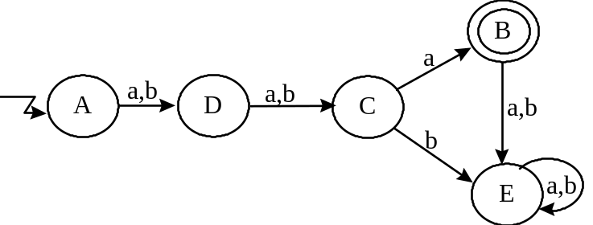

Exercise. Apply the construction algorithm given above to obtain the minimal-state DFA equivalent to DFAs that have appeared on exams and problem sets.

